Bahria University,
Karachi Campus


COURSE: Introduction to Data Science
TERM: Fall 2025, CLASS: BSE- 5 (c)

Emotion-Based Music Recommendation System using Real-Time Facial Expression Analysis

Engr. Aamana

S.NO | Student Name | Enrollment #
1 | Alishba Maqsood (TEAM LEAD) | 02-131232-118
2 | Muhammad Abubakar Afzal | 02-131232-052
3 | Fiza Khan | 02-131232-048

Submitted on: 22/12/25

Signed Remarks: Score:

INTRODUCTION
- Project Background
The Emotion-Based Music Recommendation System is an intelligent application designed to enhance user experience by providing personalized music based on real-time emotional state. The system utilizes facial expression analysis to detect emotions and recommends music playlists accordingly. By integrating computer vision, machine learning, and music streaming services, this project aims to create an interactive and emotionally-responsive digital environment, reducing the need for manual playlist selection and offering a novel way to enjoy music.
- Reference Application
This system draws inspiration from existing emotion-aware applications such as Spotify's mood-based playlists and AI-powered emotion recognition tools like Microsoft's Emotion API. These platforms highlight the growing trend of using affective computing to personalize digital experiences, particularly in entertainment and mental well-being applications.
- Project Objectives
- To develop a real-time facial emotion detection system using a Convolutional Neural Network (CNN) model.
- To classify emotions into seven categories: Angry, Disgust, Fear, Happy, Neutral, Sad, and Surprise.
- To integrate with Spotify API to fetch and embed emotion-specific music playlists.
- To create a user-friendly web interface using Streamlit for seamless interaction.
- To ensure system responsiveness and compatibility across different devices.

SYSTEM OVERVIEW
- Key Features:
- Real-time Face Detection: Uses OpenCV and Haarcascade for continuous face detection from webcam feed.
- Emotion Classification: Implements CNN model to classify facial expressions into 7 emotion categories with confidence scoring.
- Web-based Interface: Streamlit-powered UI with start/stop webcam controls and real-time emotion display
- Music Integration: Connects to Spotify API to fetch and embed emotion-specific playlists
- Session Management: Maintains user session state for seamless interaction and emotion tracking

Responsive Design: Adapts to different screen sizes with proper layout and component sizing.
- Dataset Details:
The core component of this project, the Convolutional Neural Network (CNN) classifier, is trained and validated using the Facial Expression Recognition (FER-2013) dataset. This public dataset is the standard benchmark for seven-class facial emotion classification, aligning precisely with the project's seven target emotion categories (Angry, Disgust, Fear, Happy, Neutral, Sad, Surprise).

Dataset Source Link: The specific dataset used, which is commonly employed in this project structure, can be found here:
https://www.kaggle.com/datasets/msambare/fer2013/data
The dataset specifications are as follows:
- Total Samples: 35,887 images.
- Image Format: All images are standardized to 48x48 pixel grayscale.
Data Split: The dataset is pre-partitioned into a dedicated Training Set (28,709 images) and a Testing Set (3,589 images).

System Design
Block Diagram
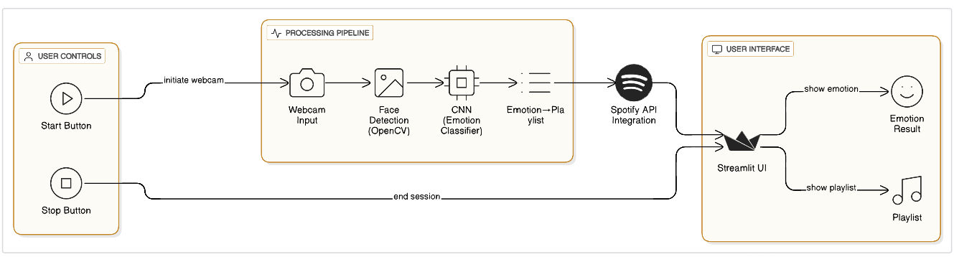
Sequence Diagram
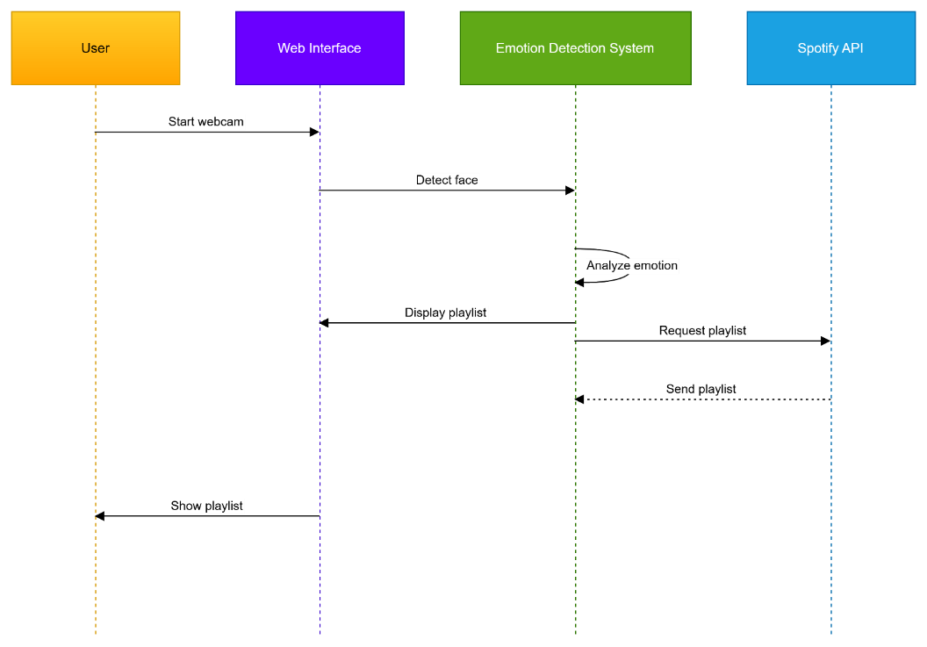

Flowchart Diagram
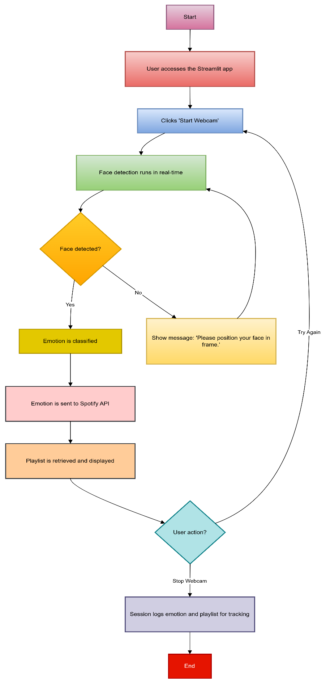

Erd Diagram

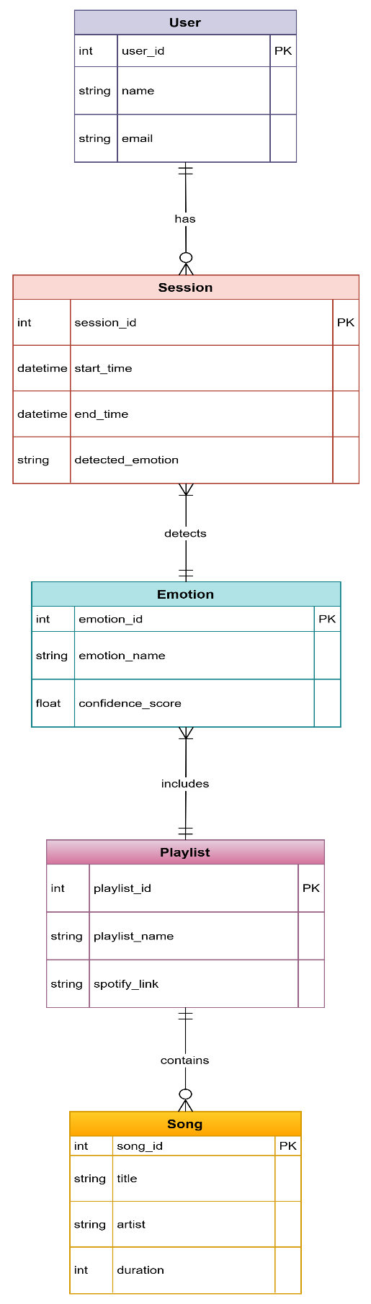

UI Mockup
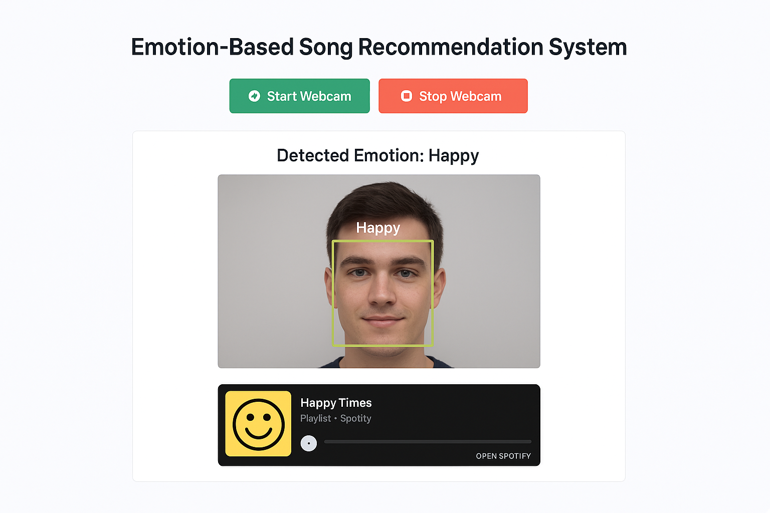

Main Logic Code
#Project_Python
import pandas as pd
import numpy as np
import matplotlib.pyplot as plt
plt.style.use('default')
import os
import tensorflow as tf
import keras
import cv2
from sklearn.model_selection import train_test_split
from tensorflow.keras.preprocessing.image import ImageDataGenerator, load_img, img_to_array
from tensorflow.keras.callbacks import EarlyStopping, ModelCheckpoint, ReduceLROnPlateau
from tensorflow.keras.utils import plot_model
from tensorflow.keras import layers , models, optimizers
from tensorflow.keras.models import Sequential, Model
from tensorflow.keras.layers import *
from tensorflow.keras.applications import ResNet50V2

train_dir = 'train/'
test_dir = 'test/'
def Classes_Count( path, name):
Classes_Dict = {}
for Class in os.listdir(path):
Full_Path = path + Class
Classes_Dict[Class] = len(os.listdir(Full_Path))
df = pd.DataFrame(Classes_Dict, index=[name])
return df
Train_Count = Classes_Count(train_dir, 'Train').transpose().sort_values(by="Train", ascending=False)
Test_Count = Classes_Count(test_dir, 'Test').transpose().sort_values(by="Test", ascending=False)

pd.concat([Train_Count,Test_Count] , axis=1)
Train_Count.plot(kind='barh')
Test_Count.plot(kind='barh')

plt.style.use('default')
plt.figure(figsize = (25, 8))
image_count = 1
BASE_URL = 'train/'

for directory in os.listdir(BASE_URL):
if directory[0] != '.':
for i, file in enumerate(os.listdir(BASE_URL + directory)):
if i == 1:
break
else:
fig = plt.subplot(1, 7, image_count)
image_count += 1
image = cv2.imread(BASE_URL + directory + '/' + file)
plt.imshow(image)
plt.title(directory, fontsize = 20)
img_shape = 48
batch_size = 64
train_data_path = 'train/'
test_data_path = 'test/'
train_preprocessor = ImageDataGenerator(
rescale = 1 / 255.,
# Data Augmentation
rotation_range=10,
zoom_range=0.2,
width_shift_range=0.1,
height_shift_range=0.1,
horizontal_flip=True,
fill_mode='nearest',
)

test_preprocessor = ImageDataGenerator(
rescale = 1 / 255.,
)

train_data = train_preprocessor.flow_from_directory(
train_data_path,
class_mode="categorical",
target_size=(img_shape,img_shape),
color_mode='rgb',
shuffle=True,
batch_size=batch_size,
subset='training',
)

test_data = test_preprocessor.flow_from_directory(
test_data_path,
class_mode="categorical",
target_size=(img_shape,img_shape),
color_mode="rgb",
shuffle=False,
batch_size=batch_size,
)

def Create_CNN_Model():

model = Sequential()
#CNN1
model.add(Conv2D(32, (3,3), activation='relu', input_shape=(img_shape, img_shape, 3)))
model.add(BatchNormalization())
model.add(Conv2D(64,(3,3), activation='relu', padding='same'))
model.add(BatchNormalization())
model.add(MaxPooling2D(pool_size=(2,2), padding='same'))
model.add(Dropout(0.25))

#CNN2
model.add(Conv2D(64, (3,3), activation='relu', ))
model.add(BatchNormalization())
model.add(Conv2D(128,(3,3), activation='relu', padding='same'))
model.add(BatchNormalization())
model.add(MaxPooling2D(pool_size=(2,2), padding='same'))
model.add(Dropout(0.25))

#CNN3
model.add(Conv2D(128, (3,3), activation='relu'))
model.add(BatchNormalization())
model.add(Conv2D(256,(3,3), activation='relu', padding='same'))
model.add(BatchNormalization())
model.add(MaxPooling2D(pool_size=(2,2), padding='same'))
model.add(Dropout(0.25))

#Output
model.add(Flatten())

model.add(Dense(1024, activation='relu'))
model.add(BatchNormalization())
model.add(Dropout(0.25))

model.add(Dense(512, activation='relu'))
model.add(BatchNormalization())
model.add(Dropout(0.25))

model.add(Dense(256, activation='relu'))
model.add(BatchNormalization())
model.add(Dropout(0.25))

model.add(Dense(128, activation='relu'))
model.add(BatchNormalization())
model.add(Dropout(0.25))

model.add(Dense(64, activation='relu'))
model.add(BatchNormalization())
model.add(Dropout(0.25))

model.add(Dense(32, activation='relu'))
model.add(BatchNormalization())
model.add(Dropout(0.25))

model.add(Dense(7,activation='softmax'))
return model

CNN_Model = Create_CNN_Model()
CNN_Model.summary()
CNN_Model.compile(optimizer="adam", loss='categorical_crossentropy', metrics=['accuracy'])

# Create Callback Checkpoint
checkpoint_path = "CNN_Model_Checkpoint.keras"
Checkpoint = ModelCheckpoint(checkpoint_path, monitor="val_accuracy", save_best_only=True)
# Create Early Stopping Callback to monitor the accuracy
Early_Stopping = EarlyStopping(monitor = 'val_accuracy', patience = 15, restore_best_weights
=True, verbose=1)
#Create ReduceLROnPlateau Callback to reduce overfitting by decreasing learning rate
Reducing_LR = tf.keras.callbacks.ReduceLROnPlateau( monitor='val_loss',
factor=0.2, patience=2, min_lr=0.000005, verbose=1)
callbacks = [Early_Stopping, Reducing_LR]
steps_per_epoch = train_data.n // train_data.batch_size
validation_steps = test_data.n // test_data.batch_size

CNN_history = CNN_Model.fit( train_data , validation_data= test_data , epochs=50,
batch_size=batch_size,callbacks=callbacks, steps_per_epoch=
steps_per_epoch, validation_steps=validation_steps)

CNN_Score = CNN_Model.evaluate(test_data)
print(" Test Loss: {:.5f}".format(CNN_Score[0]))
print("Test Accuracy: {:.2f}%".format(CNN_Score[1] * 100))
CNN_Model.save("CNN_Model_Final_Saved2.0.keras")

from tensorflow.keras.models import load_model
# Load the saved model
loaded_model = load_model("CNN_Model_Final_Saved.keras")
# Evaluate the model on the test data
CNN_Score = loaded_model.evaluate(test_data)
# Print the results
print("Test Loss: {:.5f}".format(CNN_Score[0]))
print("Test Accuracy: {:.2f}%".format(CNN_Score[1] * 100))

def plot_curves(history):
loss = history.history["loss"]
val_loss = history.history["val_loss"]
accuracy = history.history["accuracy"]
val_accuracy = history.history["val_accuracy"]
epochs = range(len(history.history["loss"]))
plt.figure(figsize=(15,5))
#plot loss
plt.subplot(1, 2, 1)
plt.plot(epochs, loss, label = "training_loss")
plt.plot(epochs, val_loss, label = "val_loss")
plt.title("Loss")
plt.xlabel("epochs")
plt.legend()

#plot accuracy
plt.subplot(1, 2, 2)
plt.plot(epochs, accuracy, label = "training_accuracy")
plt.plot(epochs, val_accuracy, label = "val_accuracy")
plt.title("Accuracy")
plt.xlabel("epochs")
plt.legend()
#plt.tight_layout()
plot_curves(CNN_history)
CNN_Predictions = CNN_Model.predict(test_data)
# Choosing highest probalbilty class in every prediction
CNN_Predictions = np.argmax(CNN_Predictions, axis=1)
test_data.class_indices

import seaborn as sns
from sklearn.metrics import confusion_matrix
fig, ax= plt.subplots(figsize=(15,10))
cm=confusion_matrix(test_data.labels, CNN_Predictions)
sns.heatmap(cm, annot=True, fmt='g', ax=ax)
ax.set_xlabel('Predicted labels',fontsize=15, fontweight='bold')
ax.set_ylabel('True labels', fontsize=15, fontweight='bold')
ax.set_title('CNN Confusion Matrix', fontsize=20, fontweight='bold')

Emotion_Classes = ['Angry', 'Disgust', 'Fear', 'Happy', 'Neutral', 'Sad', 'Surprise']
# Shuffling Test Data to show diffrent classes
test_preprocessor = ImageDataGenerator( rescale = 1 / 255., )
test_generator = test_preprocessor.flow_from_directory(test_data_path,class_mode="categorical",
target_size=(img_shape,img_shape),color_mode="rgb",shuffle=True,batch_size=batch_size,)

# Display 10 random pictures from the dataset with their labels
Random_batch = np.random.randint(0, len(test_generator) - 1)
Random_Img_Index = np.random.randint(0, batch_size - 1 , 10)
fig, axes = plt.subplots(nrows=2, ncols=5, figsize=(25, 10),subplot_kw={'xticks': [],
'yticks': []})
for i, ax in enumerate(axes.flat):
Random_Img = test_generator[Random_batch][0][Random_Img_Index[i]]
Random_Img_Label = np.argmax(test_generator[Random_batch][1][Random_Img_Index[i]])
Model_Prediction = np.argmax(CNN_Model.predict( tf.expand_dims(Random_Img, axis=0)
, verbose=0))
ax.imshow(Random_Img)
if Emotion_Classes[Random_Img_Label] == Emotion_Classes[Model_Prediction]:
color = "green"
else:
color = "red"
ax.set_title(f"True: {Emotion_Classes[Random_Img_Label]}\n
Predicted:{Emotion_Classes[Model_Prediction]}", color=color)
plt.show()
plt.tight_layout()

from tensorflow.keras.models import load_model
from tensorflow.keras.optimizers import Adam
# Load the model
model = load_model("CNN_Model_Final_Saved.keras")
# Compile the model (if you need metrics for evaluation or further training)
model.compile(optimizer=Adam(learning_rate=0.001),loss='categorical_crossentropy',
metrics=['accuracy'])
print("Model compiled successfully!")

Frontend Code:
import streamlit as st
import cv2
import numpy as np
import tensorflow as tf
from tensorflow.keras.models import load_model
import spotipy
from spotipy.oauth2 import SpotifyClientCredentials

# Load Haarcascade for face detection
face_cascade = cv2.CascadeClassifier(cv2.data.haarcascades + 'haarcascade_frontalface_default.xml')

# Load the trained model
model = load_model("CNN_Model_Final_Saved.keras")
emotion_labels = ["Angry", "Disgust", "Fear", "Happy", "Neutral", "Sad", "Surprise"]

# Spotify Authentication
sp = spotipy.Spotify(auth_manager=SpotifyClientCredentials(client_id="9c4ca04644f14ef682a98d748992b3cc",
client_secret="ba5487ae938747689fd7d44882a997f9"))

# Emotion-to-Spotify Playlist Mapping
emotion_playlists = {
"Angry": "0KPEhXA3O9jHFtpd1Ix5OB",
"Disgust": "37i9dQZF1DX4WYpdgoIcn6",
"Fear": "37i9dQZF1DX7XfRr4cb6cr",
"Happy": "37i9dQZF1DXdPec7aLTmlC",
"Neutral": "37i9dQZF1DWWQRwui0ExPn",
"Sad": "37i9dQZF1DX7qK8ma5wgG1",
"Surprise": "37i9dQZF1DX9XIFQuFvzM4"
}

# Preprocess the frame for the model
def preprocess_frame(frame):
resized_frame = cv2.resize(frame, (48, 48)) # Resize to match the model input size
if len(resized_frame.shape) == 2: # If grayscale, convert to RGB
resized_frame = cv2.cvtColor(resized_frame, cv2.COLOR_GRAY2RGB)
elif resized_frame.shape[-1] == 1: # If single channel, expand to 3 channels
resized_frame = np.concatenate([resized_frame] * 3, axis=-1)
img_array = np.expand_dims(resized_frame, axis=0) # Add batch dimension
img_array = img_array / 255.0 # Normalize pixel values
return img_array

# Predict emotion from the face
def predict_emotion(face):
processed_face = preprocess_frame(face)
predictions = model.predict(processed_face)
return emotion_labels[np.argmax(predictions)]

# Get Spotify playlist iframe for detected emotion
def get_spotify_playlist_iframe(emotion):
playlist_id = emotion_playlists.get(emotion)
if playlist_id:
iframe_code = f"""
<iframe style="border-radius:12px"
src="https://open.spotify.com/embed/playlist/{playlist_id}?utm_source=generator&theme=0"
width="100%"
height="500"
frameBorder="0"
allow="autoplay; clipboard-write; encrypted-media; fullscreen; picture-in-picture"
loading="lazy">
</iframe>
"""
return iframe_code
else:
return "No playlist available for this emotion."

# Streamlit UI
st.title("Emotion-Based Song Recommendations System 🎶")

# Webcam Control Buttons
if "run_webcam" not in st.session_state:
st.session_state.run_webcam = False
if "detected_emotion" not in st.session_state:
st.session_state.detected_emotion = None

# Start and Stop Webcam
if not st.session_state.run_webcam:
if st.button("Start Webcam"):
st.session_state.run_webcam = True
else:
if st.button("Stop Webcam"):
st.session_state.run_webcam = False
st.session_state.detected_emotion = None

# Webcam and Emotion Detection
if st.session_state.run_webcam:
cap = cv2.VideoCapture(0)
video_feed = st.empty()
emotion_display = st.empty()
playlist_display = st.empty()

# Real-time webcam feed with face detection
while st.session_state.run_webcam:
ret, frame = cap.read()
if not ret:
st.error("Failed to access the webcam.")
break

# Flip the frame horizontally for a mirrored view
frame = cv2.flip(frame, 1)

# Detect faces
gray_frame = cv2.cvtColor(frame, cv2.COLOR_BGR2GRAY)
faces = face_cascade.detectMultiScale(gray_frame, scaleFactor=1.1, minNeighbors=5, minSize=(48, 48))

# Process detected faces
for (x, y, w, h) in faces:
face = frame[y:y + h, x:x + w] # Crop the face region
detected_emotion = predict_emotion(face)
st.session_state.detected_emotion = detected_emotion

# Draw rectangle around face and display detected emotion
cv2.rectangle(frame, (x, y), (x + w, y + h), (255, 0, 0), 2)
cv2.putText(frame, detected_emotion, (x, y - 10), cv2.FONT_HERSHEY_SIMPLEX, 1, (255, 255, 255), 2)

# Display video feed and detected emotion
video_feed.image(frame, channels="BGR", caption="Webcam Feed")
if st.session_state.detected_emotion:
emotion_display.write(f"**Detected Emotion:** {st.session_state.detected_emotion}")
playlist_iframe = get_spotify_playlist_iframe(st.session_state.detected_emotion)
playlist_display.markdown(playlist_iframe, unsafe_allow_html=True)

cap.release()
st.write("Webcam stopped.")

Detailed Code Explanation

1) Training & Evaluation Code:
This section explains how Convolutional Neural Network (CNN) is trained on FER-2013-like data, evaluated, visualized, and saved for deployment. The code relies on TensorFlow/Keras for model building, OpenCV for quick image I/O, NumPy/Pandas/Matplotlib for data handling and plots.

Imports & Why They Are Needed
• pandas/numpy: tabular and numerical utilities.
• matplotlib: plotting class counts and training curves.
• cv2 (OpenCV): reading images and simple visual checks.
• tensorflow.keras: model layers, training loops, callbacks, and image generators.
• sklearn.metrics: confusion matrix to diagnose class-wise errors.

Dataset Structure, Counts, and Sanity Plots
The code expects a directory layout like train/<class_name>/ and test/<class_name>/. It counts images per class to reveal imbalance and draws simple bar charts. This helps us to decide on data augmentation & class weighting.

ImageDataGenerator & Augmentation
Images are rescaled to [0,1] and augmented (small rotations, shifts, zooms, horizontal flips). Augmentation expands the effective training set and reduces overfitting. The dataset is grayscale (FER-2013 is 48×48 grayscale), therefore we choose color_mode='grayscale' and input_shape=(48,48,1) to keep the model compact.

CNN Architecture
The model stacks three convolutional blocks (with Batch Normalization, MaxPooling, and Dropout) to learn spatial features, then flattens and passes them to Dense layers before a 7-way softmax. BatchNorm stabilizes training; Dropout regularizes to reduce overfitting.

Callbacks (EarlyStopping, ReduceLROnPlateau, Checkpoint)
EarlyStopping halts training when validation accuracy stops improving and restores the best weights. ReduceLROnPlateau automatically lowers the learning rate when validation loss plateaus. ModelCheckpoint saves the best model. Ensure the checkpoint is actually added to the callbacks list.

Training, Saving, and Evaluation
The model is trained for up to 50 epochs with mini-batches (default 64). After training, it is evaluated on the held-out test set and saved to disk.

Diagnostics: Curves, Confusion Matrix, Random Predictions
Loss/accuracy curves show under/overfitting trends. The confusion matrix highlights which emotions are confused (e.g., Neutral vs Sad). Random prediction grids give a qualitative sense of correctness; correct titles in green, incorrect in red.

2) Streamlit Frontend:
The Streamlit app opens the webcam, finds faces, predicts the emotion for each detected face using the saved CNN, and embeds a Spotify playlist that matches the emotion.

Face Detection & Model Loading
OpenCV’s Haarcascade quickly detects frontal faces. The saved Keras model is loaded once and reused for predictions. Define the emotion label order to match training classes.

Preprocessing & Prediction
Each face crop is resized to 48×48, normalized to [0,1], and converted to the channel format your model expects. The model returns probabilities for 7 classes; the argmax label becomes the detected emotion.

Spotify Integration
A simple map connects each emotion to a playlist ID. The app embeds an iframe for the chosen playlist. Avoid hard-coding client_id and client_secret; keep them in environment variables or Streamlit secrets for security.

Streamlit UI & Session State
Start/Stop buttons control the webcam. Session state keeps the latest detected emotion between reruns. The live frame is drawn with bounding boxes and labels; the right panel shows the corresponding playlist.

Testing
- Input/Output Screenshots:
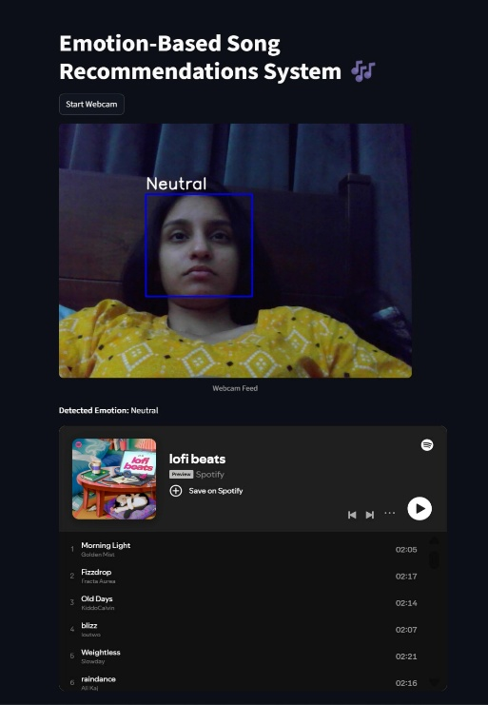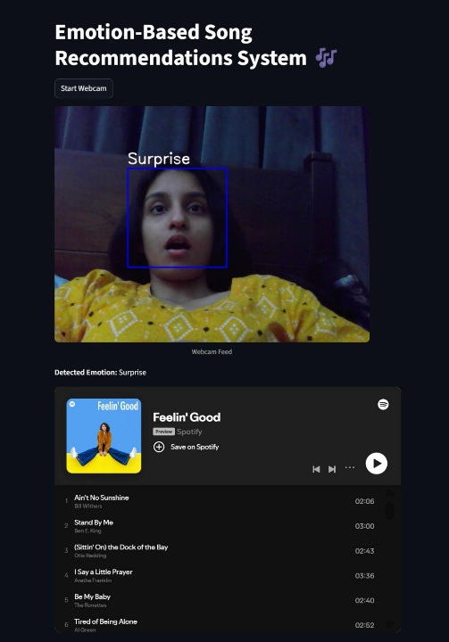
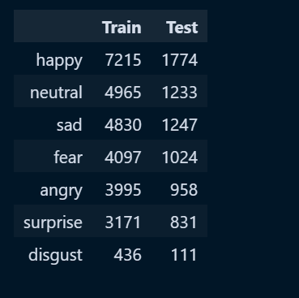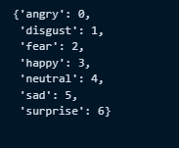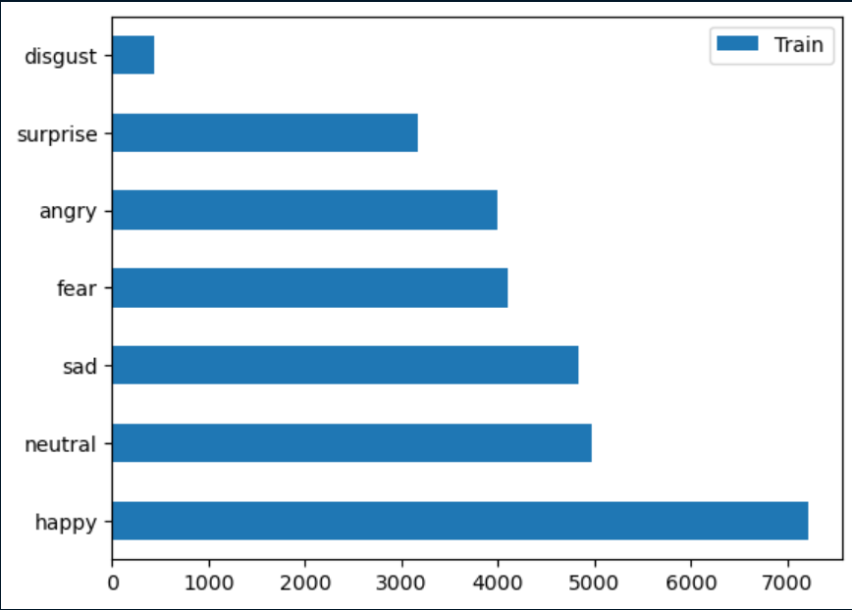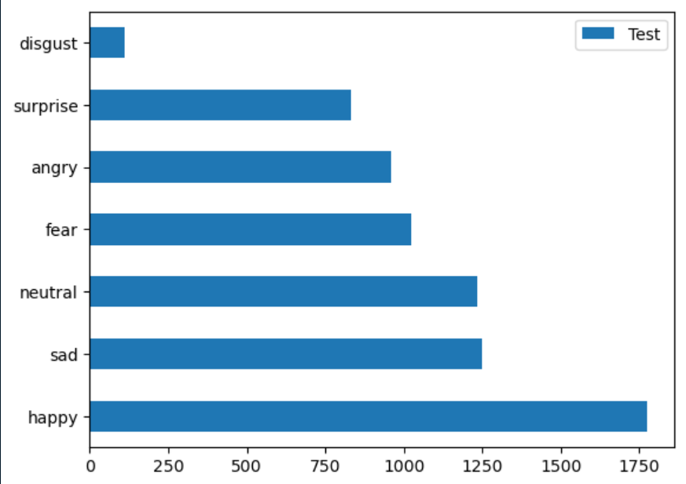
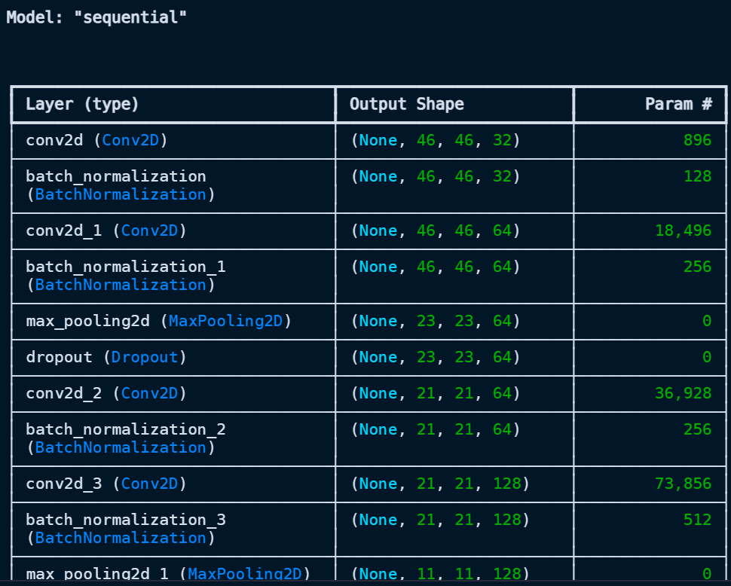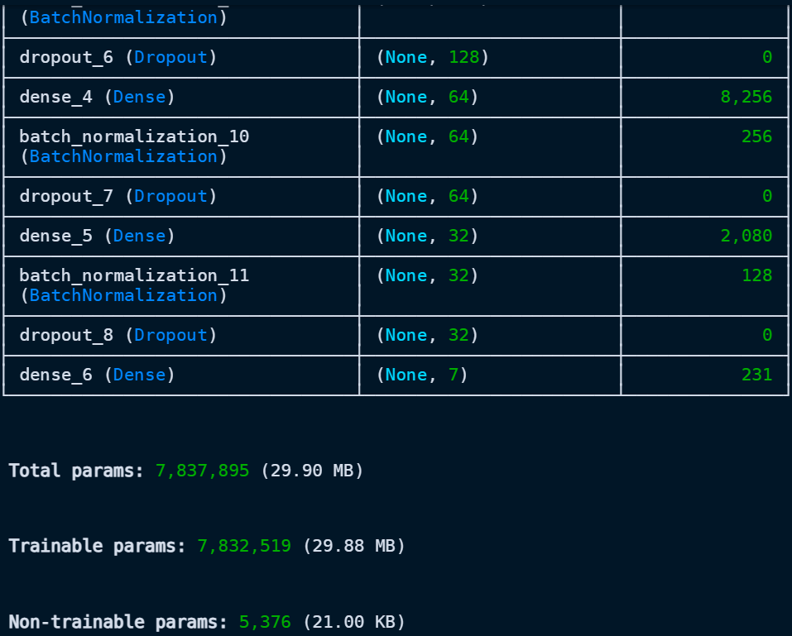
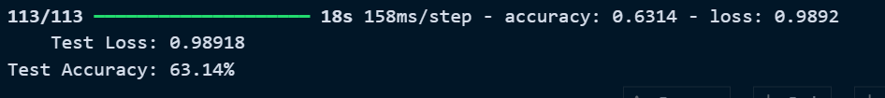
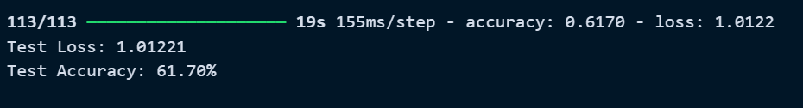
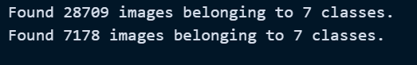
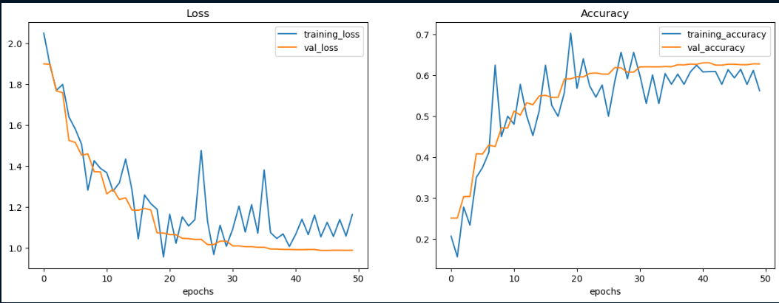
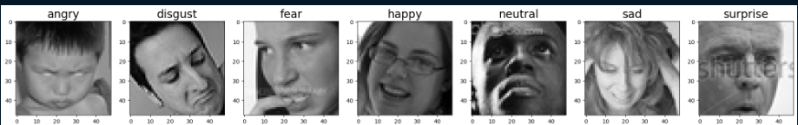
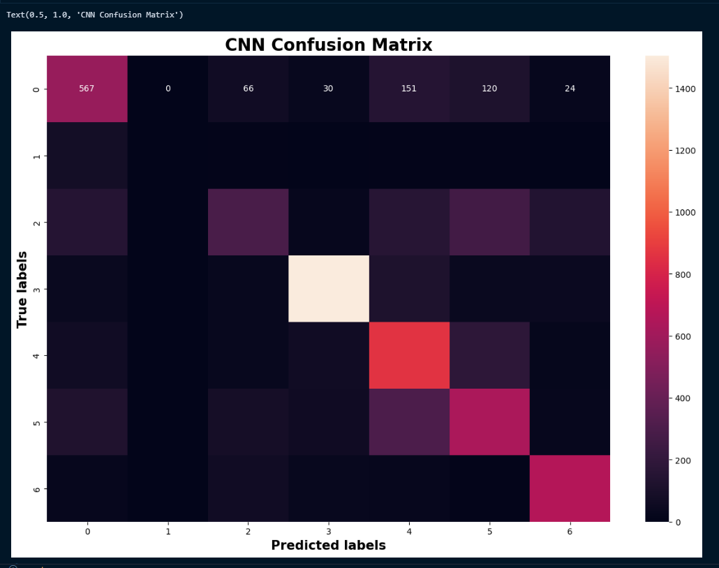
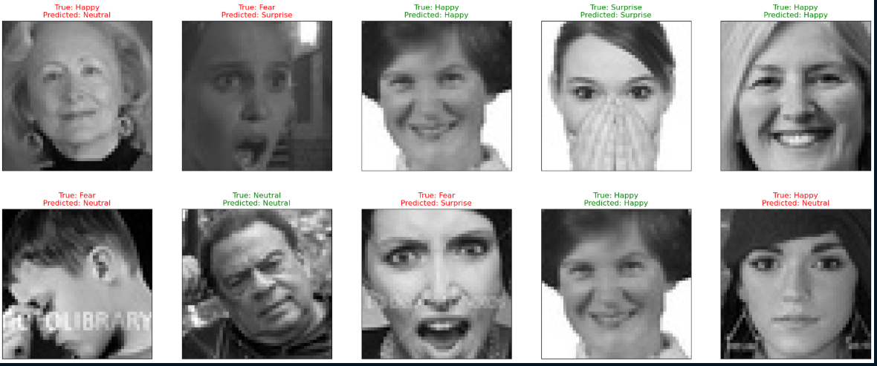
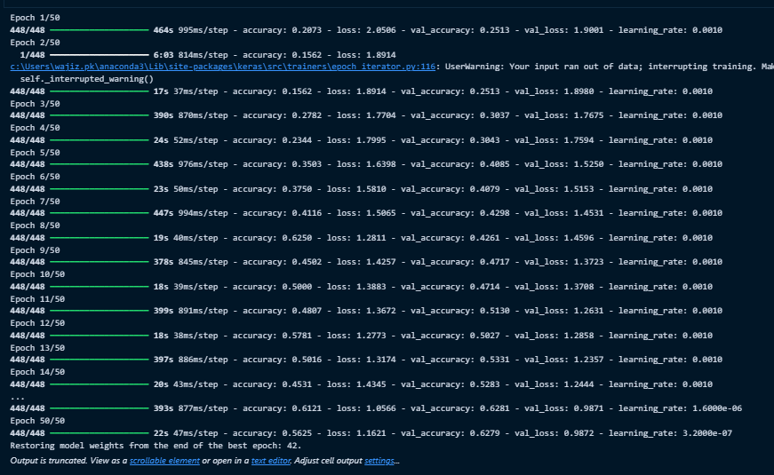

- Results:
The CNN model achieved 60%+ accuracy on FER-2013 for seven emotion classes. Real-time facial expression detection and Spotify playlist integration worked smoothly via Streamlit. Minor misclassifications occurred under poor lighting or occluded faces.

Conclusion
- Summary:
The project successfully developed an intelligent music recommendation system that detects real-time facial expressions using a Convolutional Neural Network (CNN) and recommends emotion-specific playlists via Spotify API. The system integrates computer vision, machine learning, and a Streamlit-based web interface to provide an interactive and personalized music experience. It supports seven emotion categories (Angry, Disgust, Fear, Happy, Neutral, Sad, Surprise) and ensures responsiveness across devices.
Challenges:
- Achieving high accuracy in emotion detection with limited dataset diversity.
- Handling real-time webcam feed efficiently without latency.
- Integrating Spotify API securely and managing authentication tokens.
- Designing a user-friendly interface that works seamlessly across different screen sizes.
- Preventing misclassification due to poor lighting or occluded facial features.

- Future Work:
• Integrate Multi-Modal Emotion Detection: Combine facial expression analysis with voice tone recognition to improve accuracy and robustness.
• Expand Music Platform Support: Add integration with other streaming services such as Apple Music, YouTube Music, and Amazon Music for broader user choice.
• Implement Adaptive Learning: Use user feedback and listening patterns to continuously refine emotion-to-music mapping for personalized recommendations.
• Develop Mobile Application: Create a dedicated mobile app for Android and iOS to enhance accessibility and user convenience.
• Enhance Privacy & Security: Introduce on-device processing for emotion detection and encrypt user data to ensure privacy compliance.

7. References
- Kaggle – FER-2013 Dataset: https://www.kaggle.com/datasets/msambare/fer2013/data
- Spotify Developer API Documentation: https://developer.spotify.com/documentation/web-api
- Microsoft Emotion API Overview: https://azure.microsoft.com/en-us/services/cognitive-services/emotion
- Streamlit Documentation: https://docs.streamlit.io

